Name: Vishal Salvi

TE Comps

2019230069 (52)

CE51, Monsoon 2020

ISE Assignment #1

Due date 20th Sept. 20@17hrs (IST)

**Instructions**:

* This Assignment is to be completed individually be each student.
* No partial credit for showing only final result, hence must show all necessary computational steps to gain credits

|  |  |  |
| --- | --- | --- |
| Q.1 | Consider a channel with bandwidth W=1 MHz and SNR =20 dB, and we want to allocate this channel among M=10 users. |  |
| a | What bit rate is available to each user if we divide the entire channel into M channels of equal bandwidth | 1 |
| b | What bit rate is available to each user if the entire frequency band is used as a single channel and TDM (time division multiplexing) is applied? | 1 |
| c | How does the comparison of (a) and (b) change if the FDM (frequency division multiplexing) scheme in (a) requires a guard band between adjacent channels? Assume the guard band is 10% of the channel bandwidth | 1 |
| Q,2 | Consider the IP network is shown below, where R is a router and S is a switch. A, B, C, and D are hosts. IP addresses and MAC addresses of hosts and router interfaces are listed as follows |  |
| a | In this question, we assume R has a complete routing table and S has a complete forwarding table. However, R’s ARP cache is empty right now.  R received a packet with the following header   |  |  |  |  |  | | --- | --- | --- | --- | --- | | Ethernet Src | Ethernet Dst | IP Src | IP Dest | Payload | | 18:AB:AC:AD:AE:AF | 3E:FF:28:29:30:31 | 192.168.1.3 | 20.2.3.2 |  |   Since R does not have anything in its ARP cache yet, it will not be able to fill in the  Ethernet Dst field before it tries to send it to next hop. Thus, R will send out an ARP request first. Which host(s) will receive this ARP request sent by R? After the device(s) received the ARP request from R, which will respond? | 1 |
| b | After the above operation was successfully completed, what would the new header of the packet that R sending out?   |  |  |  |  |  | | --- | --- | --- | --- | --- | | Ethernet Src | Ethernet Dst | IP Src | IP Dest | Payload | |  |  |  |  |  | | 1 |
| c | After the above operation was successfully completed, would R send out ARP requests again for this incoming packet? (2 pts)   |  |  |  |  |  | | --- | --- | --- | --- | --- | | Ethernet Src | Ethernet Dst | IP Src | IP Dest | Payload | | 18:AB:AC:AD:AE:AF | 3E:FF:28:29:30:31 | 192.168.1.3 | 20.2.3.8 |  | | 1 |
| Q.3 | Consider a code on six-bit strings that contains (only) the following four codewords:  000000, 000011, 001111, 111111 |  |
| a | What is the hamming distance of this code? | 1 |
| b | What is the rate of this code if we use it to encode two-bit strings? Is it efficient?  If it is not efficient, please explain | 1 |
| c | How many bit flips can be using this code detected? How many bit flips can be corrected? | 1 |
| d | What is the max burst error that can be detected with generator *x*4 + *x*3 + 1? | 1 |

|  |  |  |
| --- | --- | --- |
| Name: Salvi Vishal | | |
| SID: 2019230069 (52) | | |
| Q.No | Marks | Score |
| 1 | 3 |  |
| 2 | 3 |  |
| 3 | 4 |  |
| Total | 10 |  |

**Answers**:

Qe 1

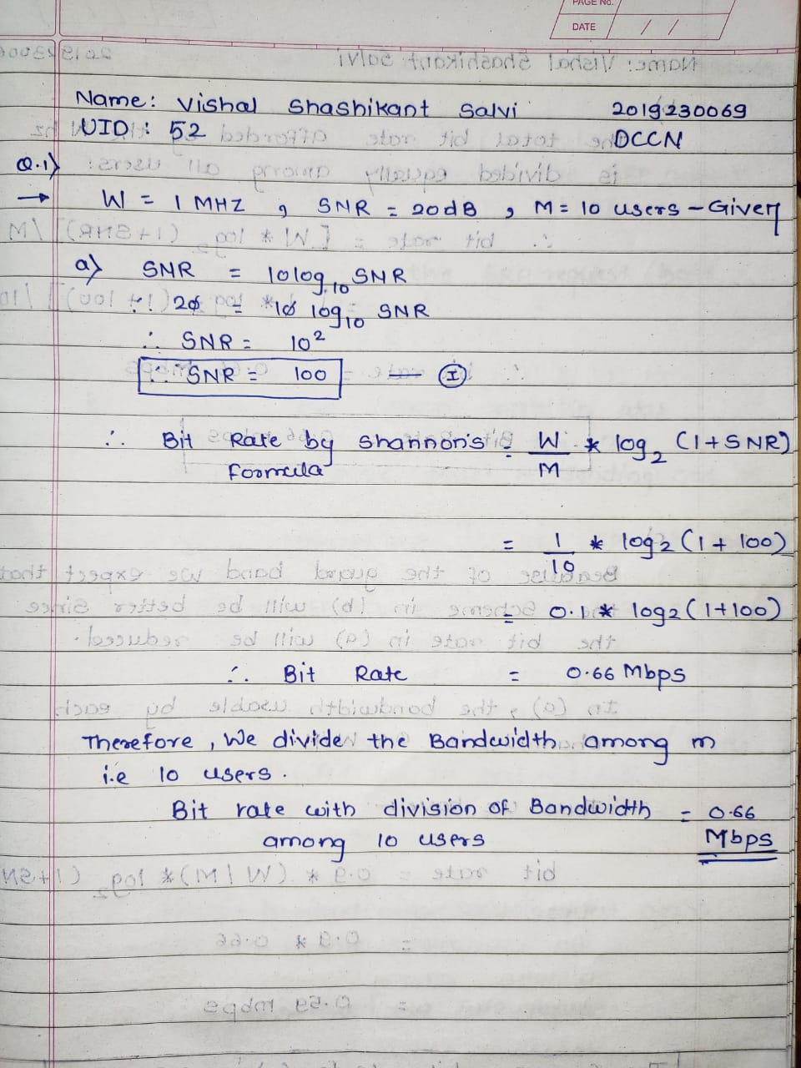

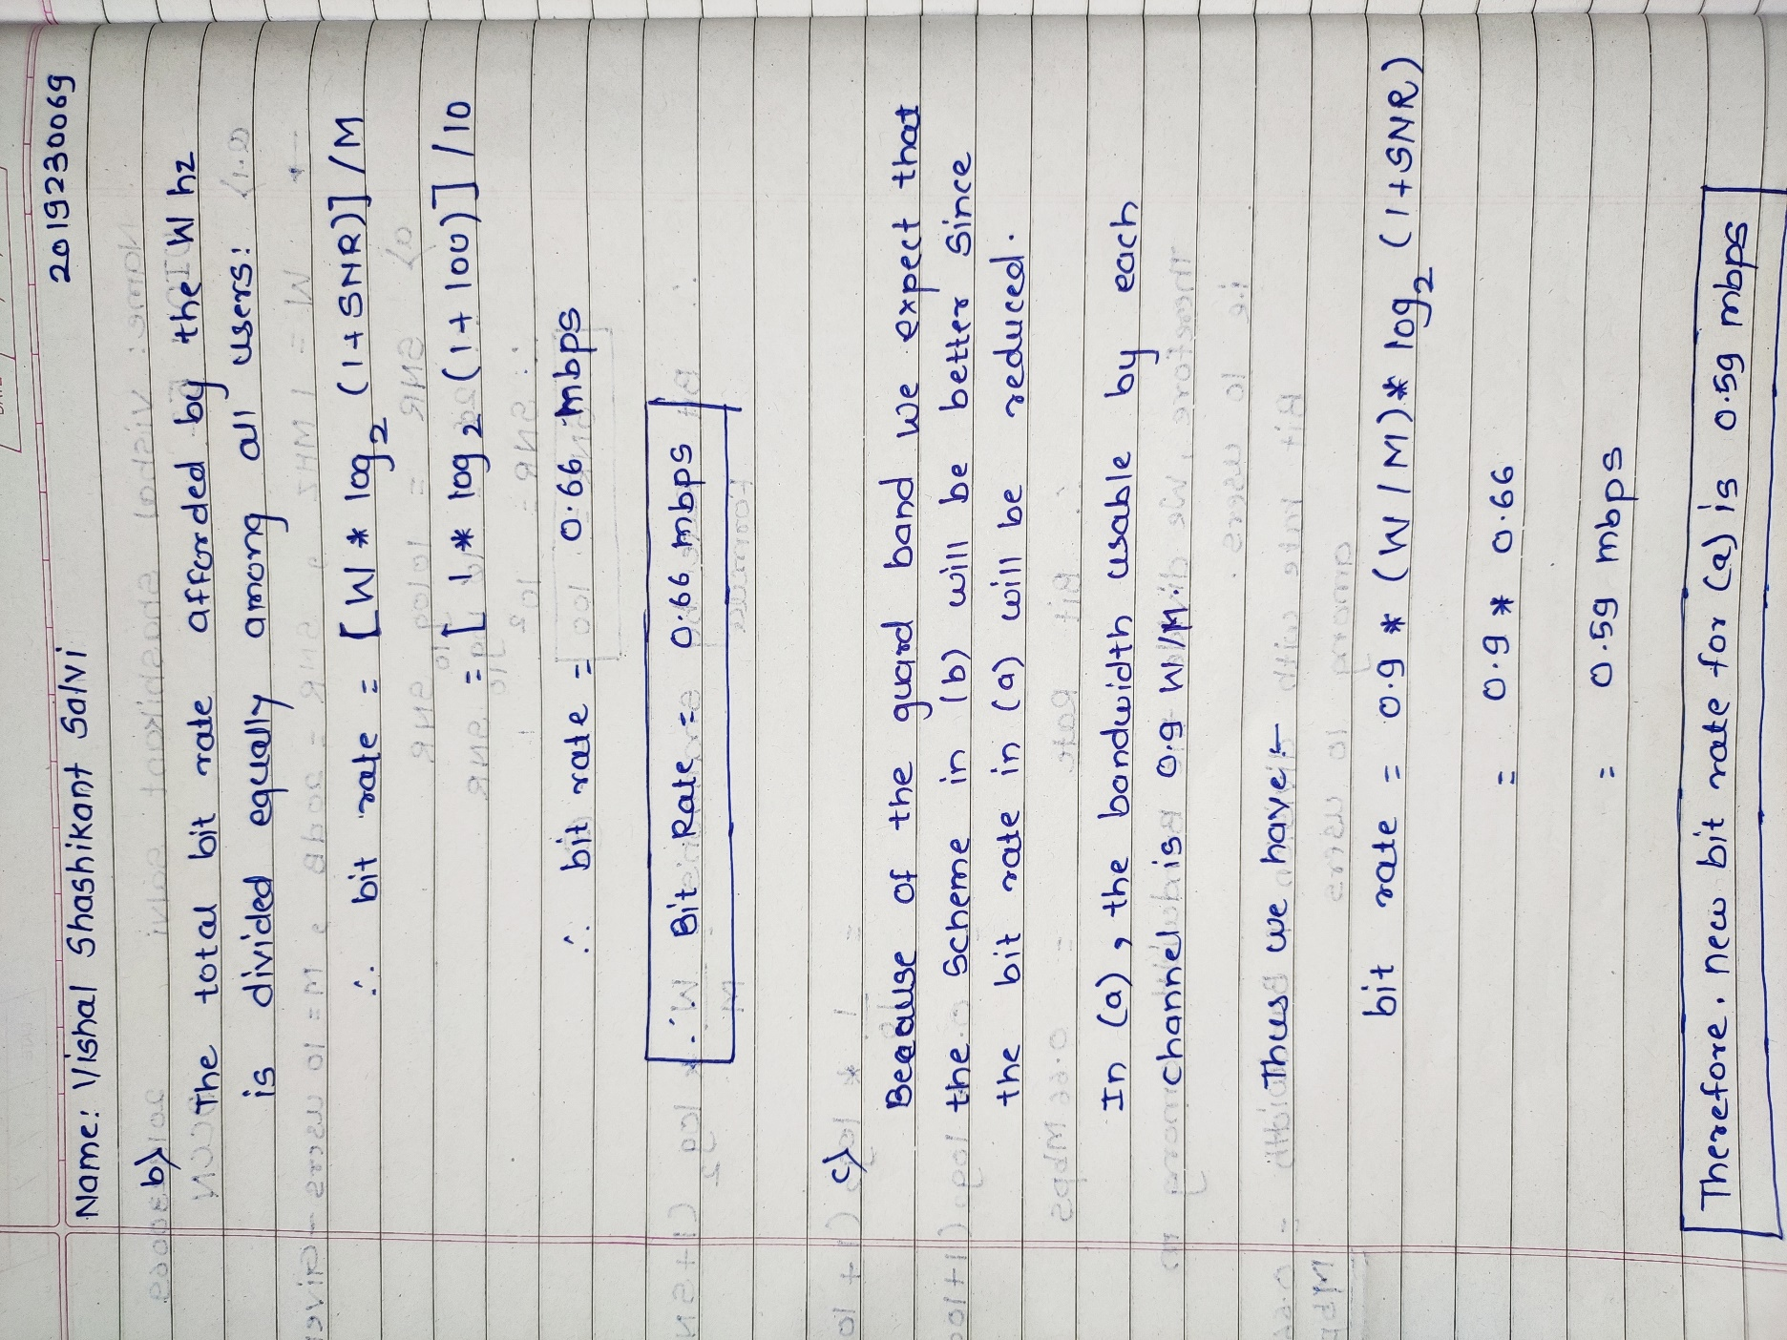

Qe 2

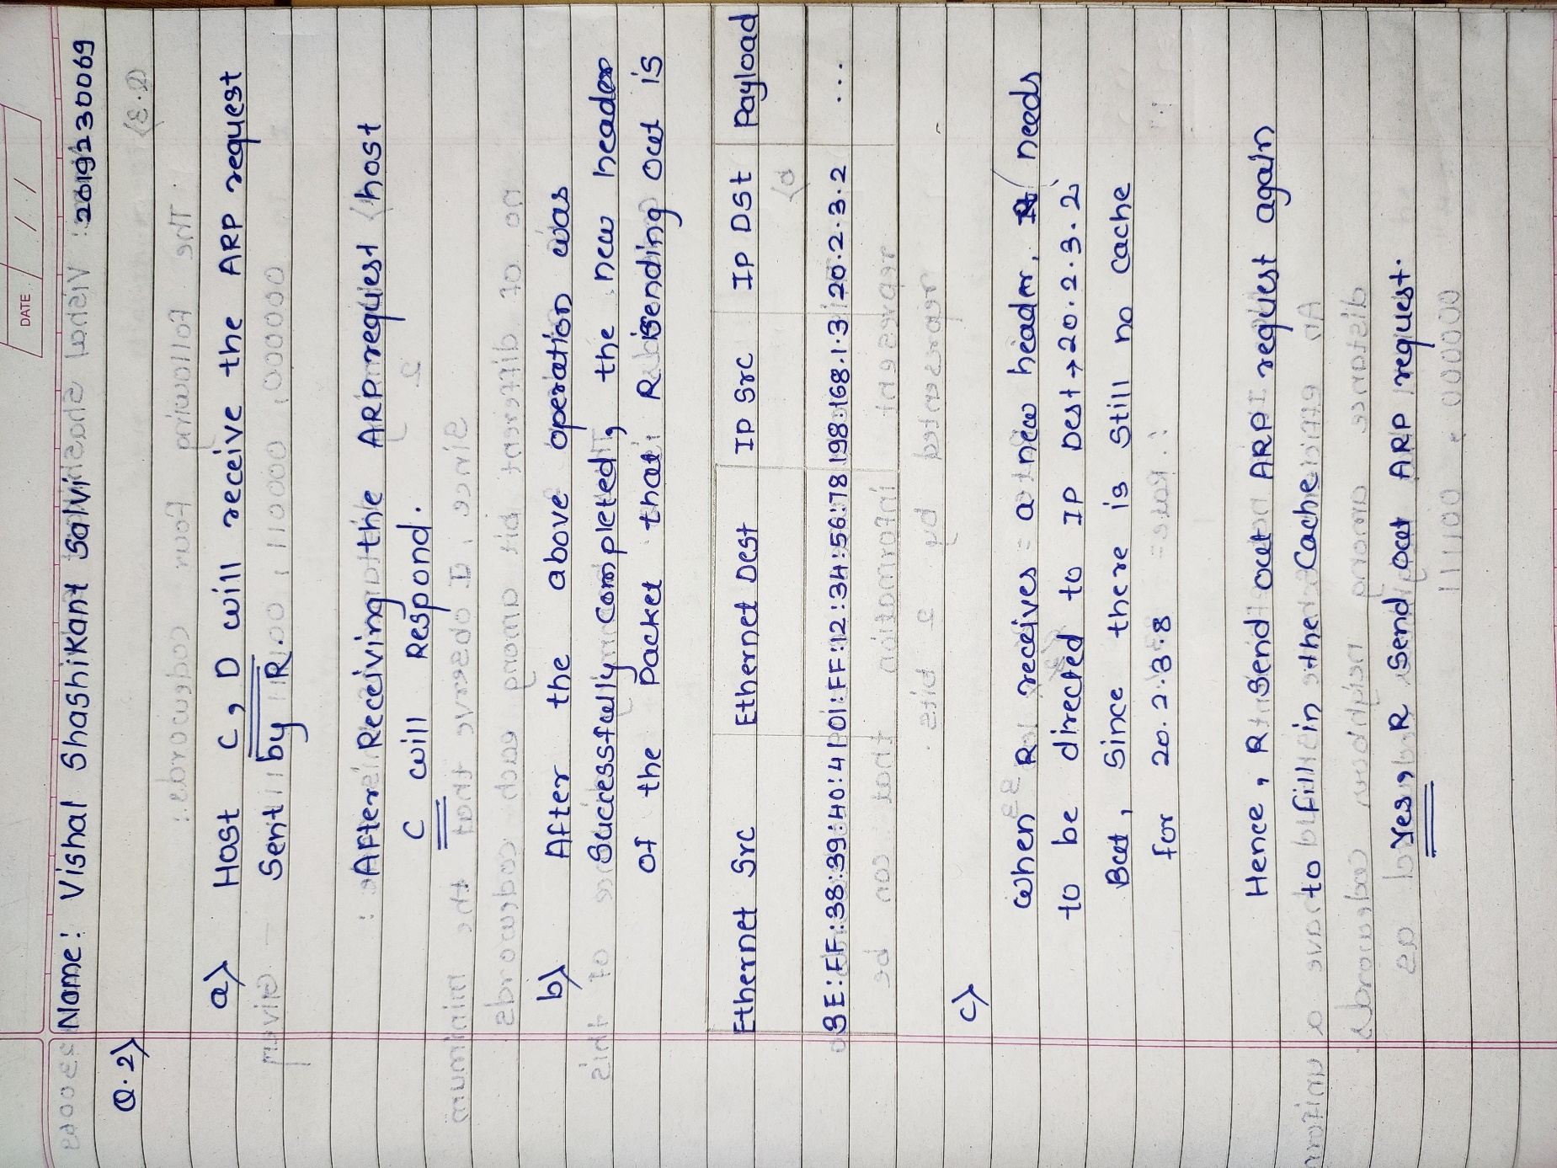

Qe 3

